**Declaration**

This is to declare the project work which is done under the supervision of instructor Mohammed shahid and having the title online bus ticket reservation system for Gondar town is the sole contribution of:

1Beydu Awol

2.Habtamu Bekele

3 .Mekrie Dubie

4. Nigatu Mengie

No part of the project work has been copy from any source. We will be responsible and liable for any consequence if violation of this declaration is proven.

Date: \_\_\_\_\_\_\_\_\_\_\_\_\_\_\_\_\_\_\_\_\_

**Group Members:** ­ Signature

Full Name

1Beydu Awol .......................................

2.Habtamu Bekele ..........................................

3 .Mekrie Dubie .........................................

4. Nigatu Mengie ............................................

**CERTIFICATE**

I certify that this BSC industrial project report entitled online bus ticket reservation for Gondar town by:

1Beydu Awol

2.Habtamu Bekele

3 .Mekrie Dubie

4. Nigatu Mengie

Is approved by me for submission? I Certify further that, to the best of my knowledge, the report represents work carried out by the students.

\_\_\_\_\_\_\_\_\_\_\_\_\_\_\_\_\_\_\_

Date Name and Signature of Supervisor

**Acknowledgment**

We would like to give our greater thanks to our adviser Mohammed shahid for his being our guidance to complete the project success fully. By providing us the necessary information. As well as Gondar bus station employee for their voluntariness for being interviewed for the required information to prepare the existing system document and our group member for their active participation to accomplish our project. Finally we would like to give our great thanks to Gondar University for providing us computer facility to complete our project.

Contents

[CHAPTER ONE 1](#_Toc404593053)

[1.1. Introduction 1](#_Toc404593054)

[1.2. Background 1](#_Toc404593055)

[1.3. Statement of the problem 2](#_Toc404593056)

[1.4. Objective of the project 2](#_Toc404593057)

[1.4.1. General objective 2](#_Toc404593058)

[1.4.2. Specific Objectives 2](#_Toc404593059)

[1.5. Scope of the project 3](#_Toc404593060)

[1.6. Limitations of Existing System 3](#_Toc404593061)

[➢ No information on the delay of bus to passengers 3](#_Toc404593062)

[➢ Slow response about refunding 3](#_Toc404593063)

[➢ Low quality customer service 3](#_Toc404593064)

[➢ High registration and service charge 3](#_Toc404593065)

[➢ They increase the bus ticket fares during festival time and public holidays 3](#_Toc404593066)

[1.7. Project requirements 4](#_Toc404593067)

[1.7.1. Functional Requirement 4](#_Toc404593068)

[1.7.2. Non – Functional Requirements 4](#_Toc404593069)

[1.8. Significance of the project 5](#_Toc404593070)

[1.9. Beneficiaries of the projects 6](#_Toc404593071)

[1.10. Feasibility analysis 6](#_Toc404593072)

[1.10.1. Operational feasibility 6](#_Toc404593073)

[1.10.2. Technical feasibility 6](#_Toc404593074)

[1.10.3. Economical feasibility (Cost Benefit Analysis) 7](#_Toc404593075)

[1.10.3.1. Benefits of the Project 7](#_Toc404593076)

[1.10.3.1.1. Tangible benefit 7](#_Toc404593077)

[1.10.3.1.2. Intangible benefits 7](#_Toc404593078)

[1.10.3.2. Cost of the Project 7](#_Toc404593079)

[1.10.3.2.1. Tangible costs 7](#_Toc404593080)

[1.10.3.2.1.1. Hardware development cost 8](#_Toc404593081)

[1.10.3.2.1.2. Miscellaneous Cost 8](#_Toc404593082)

[1.10.4. Schedule Feasibility 9](#_Toc404593083)

[1.11. System development Methodology 10](#_Toc404593084)

[Chapter Two 13](#_Toc404593085)

[Analysis 13](#_Toc404593086)

[2. Introduction 13](#_Toc404593087)

[2.1. Description of the existing system 13](#_Toc404593088)

[2.2. Essential use Case diagram 14](#_Toc404593089)

[2.3. User interface prototyping 17](#_Toc404593090)

[2.4. Business rules of the new system 18](#_Toc404593091)

[2.5. Proposed system Description 19](#_Toc404593092)

[2.5.1. Input of the proposed system 19](#_Toc404593093)

[2.5.2. Output of the proposed system 19](#_Toc404593094)

[2.5.3. Activities of the proposed system 20](#_Toc404593095)

[2.7 Functional Requirement 20](#_Toc404593096)

[2.8 Non – Functional Requirements 20](#_Toc404593097)

[2.6. Use Cases diagram 22](#_Toc404593098)

[2.9.1. Essential Use case Description 22](#_Toc404593099)

[CHAPTER THREE 28](#_Toc404593100)

[3. System Design 28](#_Toc404593101)

[3.1 Subsystem decomposition 28](#_Toc404593102)

[3.2 Proposed System Architecture 28](#_Toc404593103)

[3.3. Sequence Diagrams for each use case 29](#_Toc404593104)

[3.4 activity diagram 39](#_Toc404593105)

[Proposed system user interface prototype 46](#_Toc404593106)

[3.5. Class Diagram 47](#_Toc404593107)

[3.6. Collaboration diagram 48](#_Toc404593108)

[3.7. State Chart diagram 56](#_Toc404593109)

[3.8. Component diagram 61](#_Toc404593110)

[3.9. Deployment modelling 62](#_Toc404593111)

[Appendix 65](#_Toc404593112)

**List of tables**

[Table 1 hardware development cost 11](#_Toc409624063)

[Table 2 miscellaneous cost 12](#_Toc409624064)

[Table 3 feasibility schedule 13](#_Toc409624065)

[Table 4 essential use case description for manager 19](#_Toc409624066)

[Table 5 essential use case description for bus owner 19](#_Toc409624067)

[Table 6 essential use case description for driver 20](#_Toc409624068)

[Table 7 essential use case description for customer 20](#_Toc409624069)

[Table 8 essential use case description for casher 20](#_Toc409624070)

[Table 9 use case for login 27](#_Toc409624071)

[Table 10 use case for customer registration 28](#_Toc409624072)

[Table 11 use case for cancellation 29](#_Toc409624073)

[Table 12 use case for update 30](#_Toc409624074)

[Table 13 use case for journey schedule 30](#_Toc409624075)

[Table 14 use case for bus information 31](#_Toc409624076)

[Table 15 use case for add manual schedule 32](#_Toc409624077)

**List of figures**

[Figure 1 use case diagram for existing system 19](#_Toc409635893)

[Figure 2 existing user interface ticket 22](#_Toc409635894)

[Figure 3 existing user interface form 22](#_Toc409635895)

[Figure 4 use case diagram for proposed system 27](#_Toc409635896)

[Figure 5 sub system decomposition 33](#_Toc409635897)

[Figure 6 proposed system architecture 34](#_Toc409635898)

[Figure 7 sequence diagram for login 36](#_Toc409635899)

[Figure 8 seqence diagram for reservation 37](#_Toc409635900)

[Figure 9 sequence diagram for journey schedule 38](#_Toc409635901)

[Figure 10 sequence diagram for bus information 39](#_Toc409635902)

[Figure 11 sequence diagram for cancellation 40](#_Toc409635903)

[Figure 12 sequence diagram for add manual sechedule 41](#_Toc409635904)

[Figure 13 sequence diagram for generate ticket 42](#_Toc409635905)

[Figure 14 sequence diagram for update database 43](#_Toc409635906)

[Figure 15 activity diagram for login 44](#_Toc409635907)

[Figure 16 activity diagram for reservation 45](#_Toc409635908)

[Figure 17 activity diagram for view schedule 46](#_Toc409635909)

[Figure 18 activity diagram for bus information 47](#_Toc409635910)

[Figure 19 activity diagram for generate ticket 48](#_Toc409635911)

[Figure 20 activity diagram for cancellation 49](#_Toc409635912)

[Figure 21 activity diagram for add manual schedule 50](#_Toc409635913)

[Figure 22 user interface for home page 51](#_Toc409635914)

[Figure 23 user interface for admin login 51](#_Toc409635915)

[Figure 24 class diagram for proposed system 52](#_Toc409635916)

[Figure 25 collaboration diagram for login 54](#_Toc409635917)

[Figure 26 collaboration diagram for generate ticket 55](#_Toc409635918)

[Figure 27 collaboration diagram for view schedule 56](#_Toc409635919)

[Figure 28 collaboration diagram for view profile 57](#_Toc409635920)

[Figure 29 collaboration diagram for add manual schedule 58](#_Toc409635921)

[Figure 30 collaboration diagram for reservation 59](#_Toc409635922)

[Figure 31 collaboration diagram for cancellation 60](#_Toc409635923)

[Figure 32 state chart diagram for login 62](file:///F:\ \uuffaaa.docx#_Toc409635924)

[Figure 33 state chart diagram for reservation 63](file:///F:\ \uuffaaa.docx#_Toc409635925)

[Figure 34 state chart diagram for cancellation 64](file:///F:\ \uuffaaa.docx#_Toc409635926)

[Figure 35 state chart diagram for add manual schedule 65](file:///F:\ \uuffaaa.docx#_Toc409635927)

[Figure 36 component diagram for proposed system 66](#_Toc409635928)

[Figure 37 deployment diagram for proposed system 67](#_Toc409635929)

**Acronyms**

**CD………………………………**compact disk

**CRC……………………………..**class responsibility collaborator

**HTML…………………………** Hyper text markup language

**MySQL………………………….**

**OBTRS…………………………….**online bus ticket reservation system

**OO………………………………..** Object oriented

**OOSAD…………………………** object oriented system analysis and design

**PHP………………………………** Preprocessing hyper text programming

**RDBMS………………………......**relational database management system

**SD………………………………….**Sequence diagram

**SRS…………………………………**soft ware requirement specification

**UI…………………………………..** User interface

**UML………………………………..**Unified model language

[**URL…………………………………**Uniform](file:///C:\Users\weinshet\Documents\desktop\gety\Uniform) resource locator

# CHAPTER ONE

## Introduction

The software program “Online Bus ticket Reservation System” provides bus transportation system, a facility to reserved seats, cancellation of seats and different types of enquiry which need an instant and quick reservation. OBTRS will be built for manage and computerize the traditional database, ticket booking and tracking bus and travel made easy. It will allow counter employee check bus ticket availability and make reservation on particular customer. It will maintains all data’s of employees, bus details, reservation details, booking details, customer details.

## Background

Gondar town found in the north western parts of Addis Ababa at 738 kilometer from the capital city of Ethiopia and 175km far apart from Bahrdar town. It is the main tourist site in Amhara+ region and has its own administration structure to organize, control and manage the local communities. In addition to this, in the town there are governmental and nongovernmental organizations which facilitate the development of the town and provide services to the community. From those governmental institutions Bus stations are one of the public centers which give transportation service for journeys. There is only one bus station in Gondar, and it was established in 1987E.C for the purpose of serving the local communities getting service in their own village. The bus station travel’s up to 73 town by assigning up to 500 bus to different destination for journey and it include other stockholder such as bus owner as well as traffic police, labor worker. The bus owner will have level1, level2and level3 buses. Even though the bus station tries to give quality of services it has its own drawback. As the fill control mechanism, time and cost wastage in the organization as well as customer service delay. In order to solve this problem automated online bus ticket reservation system is proposed for a selected town that is tourist site and for town that take repeated journey spatially for student at the time of registration.

## Statement of the problem

* The current system works as manually
* manually System that are using by the staff at the counter currently is an internal system and just used to sell the bus ticket at the counter
* Customer has to go to the counter to buy bus ticket or ask for bus schedule.
* Furthermore Customers need to pay cash when they buy bus tickets and sometimes needs to queue up for hours to get bus tickets
* Customer is not sure about availability of open windows to get ticket
* Besides that, customers are also not allowed to buy bus tickets through telephone because the bus company's telephone line is always busy
* The organization waste resource and time for handling records.
* The File control mechanism is very tedious, Complicated and not secured. Because every task recorded manually and difficulty to view each record and data recorded not secure. .
* To create connection between branches and customer the manual system made difficulty the services.

## Objective of the project

## General objective

The general objective of the project is to develop Online Bus Ticket Reservation System for Gondar Town bus station.

## Specific Objectives

To achieve the general objectives our project, we are able to know the following specific objectives:

* It facilitate a web based buying bus ticket function. Customer can buy bus ticket through online system and no need to stand to buy bus ticket at counter window.
* To provide any time any place service to the customer So customer can buy bus ticket 24X7 basis
* To enable customer to check the availability of the bus ticket online. Customer can check the time departure and arrival for every bus through the system.
* customer can hold the ticket online. And later they can pay at counter with in 48 hour.
* The numbers of staff at the counter can be reducing after the online buying bus ticket system launch.
* To develop authentication for security spatially for the administrator.
* To design a secure database. For view schedule, bus information. And Ticket reservation.

## Scope of the project

The scope of the online bus ticket reservation system is:

A person should be able to

* Login to the system through the first page of the application
* Change the password after logging into the system
* Query the buses for two weeks (Only two weeks advance reservation is available).
* No reservation before two days can be done.
* Display updated information.
* Design ticket reservation form.
* Develop link to view bus schedule
* Develop view for bus information
* Able to choose the seats which are available for a certain class.
* A mail should be send to the concerned person about the confirmation of the ticket to the specified email address.

## Limitations of Existing System

## No information on the delay of bus to passengers

## Slow response about refunding

## Low quality customer service

## High registration and service charge

## They increase the bus ticket fares during festival time and public holidays

## Project requirements

## Functional Requirement

Functional requirement tell as what the system does in order to give quality services for customer.

* Bus station reservation services.
* View online bus station services.
* Validates data entry for correctness.
* Sell serial number to customers.
* Display updated journeys schedule online.
* Display updated buses information.
* Provide serial No for the reserved ticket request.

## Non – Functional Requirements

Nonfunctional requirement show the technical aspects that the system must fulfill. Or the indirect function of the system during process.

* **Error Handling Exception**– the system should be able to handle exceptions like input mismatch exception such as interchanging numeric and characters in the user inter face in order to fill the form such correction taken by the PHP program java script that restrict the interred data is with range 1-9 or the character is upper or lower case as well as the limit the number or character should under taken in the user account by show an alert ”sorry the services are not working for the time being”
* **Security –** the system should be secured from unauthorized access by assigning password and use name to get each services of the bus station any by excluding the free services such as view bus information and view journey schedule. As will as show an alert for an authorizes access to the privilege.
* **Performance** – the system should give service with maximum performance as fast as customer enter required information to get the services of the bus station. At a time one customer can get the services form one system.
* **Accuracy** – the system should be accurate and error free at lest it has to give alert when user inset incorrect data to the system and it has to display available services in the bus station to the customer through the database daily updated information by the administrator .
* **Reliability** – the system should be reliable all the time the users accesses the system .as Mach as there is no power loss the services provided by the system should be available for the customer.
* **No redundancy –** the system should avoid repetition of data on the database by checking each day the available or not available services from the bus station
* **Availability –** all the data on the system should be available all the time the customer require for services as well as the administrator update the information**.**
* **Efficiency –** the system must give service using minimum cost, memory storage, time and human power as much as possible through using the internet to decrease number of employee, row materials and training cost as well as other cost.
* **User friendly interface –** the system should target the users need and user friendly .by making the inter face attractive and understandable by users starting from the font ,color ,word used and other thing should take the attention of the customer and using language like English and Amharic.
* **Flexibility:** the system able to change to suite new condition or situation. This can be the daily information change each time should be insert in to the data base and if additional thing needed to be inserted in the future can be included easily

## Significance of the project

* The system will perform fast service at minimum time interval.
* It minimizes the workload of employees.
* It minimizes loss of documents as well as material wastage.
* It minimizes time to retrieve, search and update file
* Time consuming activities will be reduced
* Reduce man power & material budget allocations
* Avoid tiredness of customers because reserve ticket online.
* Avoid tiredness to separate the expired file from the unexpired files.
* Give serial number to identify customer.

## Beneficiaries of the projects

**Administrator**

To make simple the work such as, file control mechanism, getting summery about required information, modify new entry and give privilege for user account, make restriction on user account.

**Customer**

Make simple works because no time limitation to get ticket as soon as user fills the form to request tickets they will acquire the services. The customers can be the student, tourist, and employee the student always faces problem at the time of registration .The system will solve student problem for bus reservation to their campus with their home town. The same as tourist make journey to different country they need guidance to make simple their trip. The system give direction about the tourist site country as well as hotel exists to serve the tourist.

## Feasibility analysis

Feasibility study is used to investigate the proposed system in multiple dimensions. It used to indicate whether the system feasible or not. Our system can be seen according to the following literals. It includes:

* Operational Feasibility
* Technical Feasibility
* Economic Feasibility

## Operational feasibility

The new system can be easily operated and accessed by the users anywhere who interact to the system. It contains user friendly commands which leads users interact to the system interfaces. And also it has Amharic and English language user interface in order to be accessible by all users. Especially as Gondar is tourist site and education center the bus station need to move with current situation.

## Technical feasibility

Technical feasibility is the measure of practicality of the specific technical solution and the availability of technical resources and expertise. Our system can be easily maintained and repaired without requiring high Experts .So Hardware’s and software’s used in this project already existing on the current computer system. So no additional hardware and software were required.

## Economical feasibility (Cost Benefit Analysis)

Economic feasibility is the process of identifying the financial benefits and costs associated with the project being developed. For the project we are working on, the current bus station has up to 16 permanent worker and other for temporary tasks .the payment increase based on the skill and experience they had in the organization. The beginning salary for the employee starts with 2400 - 4500 so in order to solve expenses and the need for skill workers the bus station requires more cost. The current proposed system will minimize costs and time to give services as Much as possible. Because the main task done by the administrator the rest thing done by the customer.

## Benefits of the Project

## Tangible benefit

Since this project is going to be dynamic web site, there is reduction cost for material that used for manual operation.

## Intangible benefits

The intangible benefits we have pointed out the system development are the following:-

* Easily access information.
* Increased flexibility
* Increase speed of activity
* Improves the confidence of the employees.

## Cost of the Project

## Tangible costs

The tangible costs to be acquired in developing the system are:-

1. Hardware development cost
2. Miscellaneous Cost

## Hardware development cost

|  |  |  |
| --- | --- | --- |
| Hardware | Performance | Price |
| 1 Computer | Pentium 4  3.2 GHz  2 Gb RAM  1800 MHz Bus Speed  120 Gb Hard Disk  Standard Display  Standard mouse  Standard Key Board | 10,000 Birr |
| 1 Printer | Laser Ink Jet  A4 Size | 8,000 |
| Network Coverage | 256 Kb  Broad Band Connection  Can Be Extended  24/7 Service | 1,100 Birr Per Year |

Table hardware development cost

## Miscellaneous Cost

The following table lists the different miscellaneous costs that we spent in the process of the development of the system.

|  |  |  |
| --- | --- | --- |
| Miscellaneous Costs | | |
| Material | Amount | Price |
| Printing | Minimum 100 pages | 200 Birr |
| Pen | 5 | 10 Birr |
| Paper | ONE DESTA | 60 Birr |
| Flash disk | 1 | 200 Birr |
| Total | ------------ | 470 Birr |

Table miscellaneous cost

## Schedule Feasibility

Schedule feasibility is making sure whether the potential time frames and Completion date can be met or not .The project team members expected the Project to be completed on time without any delay. This represented by giant chart under project schedule, see giant chart.

Table feasibility schedule

|  |  |  |  |  |  |  |  |  |  |  |
| --- | --- | --- | --- | --- | --- | --- | --- | --- | --- | --- |
| Project phase | Activity | Nov  01-11-2014 | Nov 25-11-2014 | Nov 26-11-14 | Dec 19-12-04 | Dec 20-12-1204 | Jan 23-01-15 | Jan 25-01-15 | May 20-05-15 | May 29-05-15 |
| Planning | Writing proposal |  |  |  |  |  |  |  |  |  |
| System analysis |  |  |  |  |  |  |  |  |  |  |
| Design of system | Design user interface |  |  |  |  |  |  |  |  |  |
| Implementation | Coding and testing |  |  |  |  |  |  |  |  |  |
| Submission 0f project |  |  |  |  |  |  |  |  |  |  |

## 

## System development Methodology

In developing online bus ticket reservation system, the following development methodologies will be applied.

**Data collection**

Data collection was one of the important tasks to analyze how activities done in existing system and developed the new system. Data for developing this system obtained   from different sources**.**

**Data collection methods**

A) **Interview**: -    was used to gather required data for the project by contacting different employees of the bus station.

Question 1 when the bus station was established?

Answer 1987.

Quetion2 up to who many destinations it will travel and how many bus travels to this destination?

Answer up to 73 destination by assigning up to 500 buses per a day.

Question3 is the bus station governmental or non-governmental organization?

Answer it is public center but it include also stake holder.

Question4 is there any spatial treatment for customer by age or healthy problem?

Answer no.

Question5 what are problem exist in the organization?

Answer queue customer wait, file control mechanism, time available for services.

B) **Observation**:-was used to gather additional data by observing the actual work being done by the staff.

C) **Document Analysis (Document & literature review):-**consulted and analyzed written materials that describe the operations conducted in the station to further strengthen and support the information that applied the above technique.

**System development analysis and design**

The methods of the system analysis and design can do through OOSAD (object-oriented system analysis and development). We use the OOSAD modelling for our project because it is considered OOSAD as easier to develop and maintain. Because of the use of OOSAD it is more preferable to apply conceptual model in order to include use case, class diagram, sequence diagram, activity diagram and so on.

**Software development lifecycle**

The data modelling techniques to our system will be water fall because it help customer and stakeholder to communicate at each phase to finish task and to proceed to the next step .this will be possible because water fail make possible to complete and never go back to the previous steps. This makes satisfy the water fail to our system. Because starting from proposal to each phase.

**Requirement tools**

We need hardware and software to implement the application software i.e. client-server web based application of **Online Bus Ticket Reservation System for GONDAR TOWN.**

**Hardware**

* Desktop computer for doing all activity, implementing the software.
* Printer for printing all document part.
* Flash to transfer data from one computer to other.

**Software**

* Edraw max for the drawing of some diagrams like use case diagram.
* PHP and MYSQL to develop our data base system.
* Microsoft word for any requirements like that of writing our documentation.
* Macro Dreamweaver to develop the static webpage of our project and to done dynamic page

# 

# Chapter Two

## Analysis

## Introduction

As the existing system most of it activities are manual within the proposed system this thing will get analysis based on the problem exist .the Analysis of the existing online bus ticket reservation system and Software Requirement Specification (SRS) are the two main activities that must be undertaken to have understanding about the existing system and the new system to be developed. Studying the existing system brings about an important contribution to the entire development process of the new system. It is after the completion of this step that we can realize what goes wrong, what activities are right and which activities should encouraged and what alternative methods should be taken to increase the level of performance of proposed system and to make fully appreciable by the organization. This document contains Software Requirement Specification (SRS) for Gonder online bus ticket reservation System (GOLBTRS).The goal of this Software Requirement Specification (SRS) is to describe over all functionality requirements of online bus ticket reservation system.

## Description of the existing system

The existing system refers the manual system that is available currently. The existing system forces customers of the bus station to come over to the bus station personally, to buy tickets, to know journey schedules, to get information about the bus station. And also the record keeping and the bus distribution handled manually.

As Customers come to the bus station office in order to get ticket, after these customers are queuing up long time in front of the office. Then ticket sale man hosts the customer one by one for large amount of time. The ticket sale man record customer data on the ticket paper and on the agenda book. The ticket is given for customer but the data recorded on the agenda is saved in the office for different purpose.

As mentioned on chapter 1 the existing system has many drawbacks that require to build an automated system. But in this case we try to see the limitations of the existing system blue print. The performance of the existing system can be evaluated by the time duration of the items waiting to be purchased by the customers and the number of customers served at a time, and this depend on the number of customers and the number of employees who give the service. If the numbers of the customers are a lot all the above statements are full filled if the employees can handle all the customers effectively and quickly, but the existing system has a problem like:

* The numbers of employees needed to handle the customers are limited.
* It takes lot of time to calculate price of each items and serve many customer at the same

**Problems around Input and out put**

* The tickets are not secured
* The authenticity of the tickets are not assured
* Time wastage matters a lot
* In terms of getting remained information

## Essential use Case diagram

An essential use case sometimes called a business use case, is a simplified, abstract, generalized use case that captures the intentions of a user in a technology and implementation independent manner. A fully documented essential use case is a structured narrative, expressed in the language of the application domain and of users, comprising a simplified, abstract, technology-free and implementation-independent description of one task or interaction. An essential use case is complete, meaningful, and well designed from the point-of-view of users in some role or roles in relation to a system and that embodies the purpose or intentions underlying the interaction.

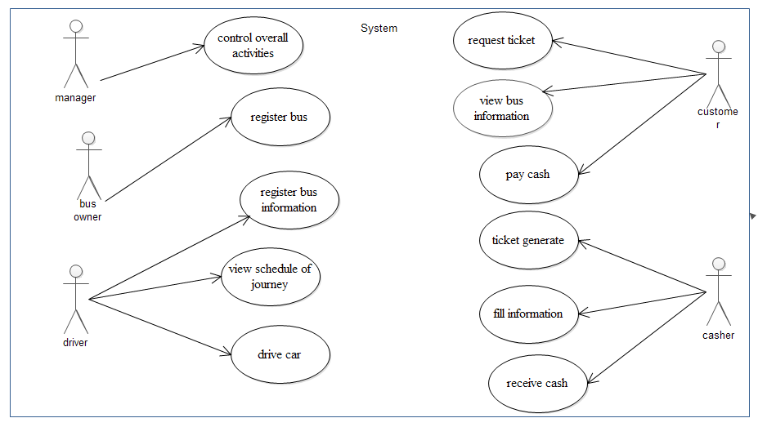

Figure use case diagram for existing system

***Essential use case for manager***

|  |  |
| --- | --- |
| UC- name | Manager |
| Use case number | UC1 |
| Actor | Manager |
| Description | Control and lead the overall activities of the organization service. |
| Basic course of action | **Actor Action**  **Step1**: receive summarized report from lower level of staff to make decision.  **Step2:**make decision based on the report obtained from the lower level |
| Alternative courses of action | Delegate power when they are busy by different activities. |
| Pre-condition | Obtain report |
| Post condition | Make decision |

Table essential use case description for manager

***Essential use case for Bus owner***

|  |  |
| --- | --- |
| UC- name | ***Bus owner*** |
| Use case number | UC2 |
| Actor | Bus owner |
| Description | Bus owner register their bus and the level of bus for the bus station |
| Basic course of action | **Actor Action**  **Step1**: register their bus for the bus station to provide service.  **Step2**: provide service based on the schedule allocated for them.  **Step3**: receive payment for the tasks they perform in the bus station. |
| Pre-condition | Ownership registration |
| Post condition | Gain profit from the service they provide |

Table essential use case description for bus owner

***Essential use case for deriver***

|  |  |
| --- | --- |
| Use case name | ***Deriver*** |
| Use case number | UC3 |
| Actor | Deriver |
| Description | Provide deriving service for the station |
| Basic course of action | **Actor Action**  **Step1**: member of the bus station deriver.  **Step2:** perform assigned tasks for deriving based on the schedule.  **Step3**: report performed task on the driving time. |
| Alternative courses of action | **Step 4:**announcement to the station if he cannot perform the task |
| Pre-condition | Having legal license |
| Post condition | Gain payment from the station. |

Table essential use case description for driver

***Essential use case for customer***

|  |  |
| --- | --- |
| UC-name | **Customer** |
| Use case number | UC4 |
| Actor | Customer |
| Description | What activities customers perform to get ticket service from the bus station. |
| Basic course of action | **Actor Action**  **Step1**: customer requests for ticket through going to the bus station.  **Step2**: tell the cashier personal information to be filled in the ticket.  **Step3:** pay money for the needed trip. |
| Pre-condition | **Step4:** Pay money |
| Post-condition | **Step5:**deliever service |

Table essential use case description for customer

***Essential use case for cashier***

|  |  |
| --- | --- |
| UC-name | **Cashier** |
| Use case number | UC5 |
| Actor | Cashier |
| Description | Receive money from customer |
| Basic course of action | **Actor Action**  **Step1**: write customers need for trip.  **Step2**: ask cash for payment  **Step3:** generate ticket for customers. |
| Pre-condition | **Step4:** gain personal information of customers |
| Post-condition | **Step5:**provide ticket |

Table essential use case description for casher

## 

## User interface prototyping

There are a number of forms and documents which are used in the existing system. The first one is the ticket that sold by the sale man and bought by customer that assure the customer to take the allocated journey.

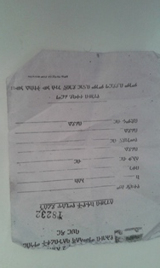

Figure existing user interface ticket

The other one is a registration form that used for the administrative office to make sure how many tickets have been given to the sale man this form is useful for both the sale man and administrative office for the case of auditing.

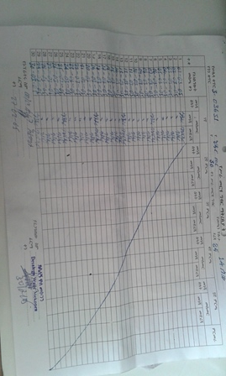

Figure existing user interface form

## 

## Business rules of the new system

A business rule is a statement that describes a business policy or procedure.

Business logic describes the sequence of operations that is associated with data in a database to carry out the rule.

Gondar bus station have their own business rules that customer follow.

**BR1**: The coder should have to give different code for each item.

**BR2**: The user should fulfill the following requirements

1. The user should be registered.
2. The user should request for the on line bus ticket request form.

**BR3**: Every customer paying cash at the time they deliver the services from the bus station.

**BR4**: When customer commands ticket for journey they should know they are reserving place for services with limited amount of day and cost.

**BR5**: only the administrator has the privilege to delete, update and insert data to the system

**BR6**: the user has no privilege to update, delete and insert data to the system.

**BR7**: If payment not completed before the day for journey the customer will not get services s

**BR8**: Returning ticket is no fully got there balance.

**BR9**: Without privilege any users will not access the system as administrator or customer

**BR10**: Every customer can have Bus information and view journey schedule without privilege

## Proposed system Description

The newly proposed system needs a web based system that customers can access the webpage wherever they are by using Internet to get tickets reservation, to know journey schedules & to get information about the bus station and it has enormous database to control the record keeping and to generate bus distribution schedule.

## Input of the proposed system

* Customer’s ticket reservation for acquiring bus station services.
* Updated information about available services.
* Customer ticket reservation and payment before the day for services.
* Up to date information must be stored in the data base.
* Use should know which privilege they have in order to access services.

## Output of the proposed system

* Costumer has info about bus station as well as view ticket schedule.
* Costumer will reserve bus ticket without spending time and cost.
* System reach customer satisfaction because of it quality, security availability and acquires of the services

## Activities of the proposed system

In order to use the proposed system we should have user or administrator privilege to log into the system. When we see the activities of the customer, by full filling the precondition such as customer registration forms being the member of the services from any were at any time. The services can be view schedule, view bus information, request ticket and view ticket.

The administrator also will have access by using the privilege to perform activities such as customer registration, bus owner registration, show schedule, generate ticket, and account confirmation to know traveling cost bus

## 2.7 Functional Requirement

The functional requirements focus on the main functions that the new application system will provide. The major functional requirements of our proposed system includes even if there are other additional functionalities going to be included.

* Customer ticket reservation.
* Ticket reservation cancellation.
* Validates data entry for correctness.
* Updates itself when it gets new data.
* Sell coupons to customers with account
* Provide ticket
* Display updated journeys schedule online
* Display updated buses information

## 2.8 Non – Functional Requirements

The non-functional requirements focus on the quality of the application systems needed to be developed from different evaluation point of view. The Non-functional requirements of our proposed system includes:-

* **Error Handling Exception**– the system should be able to handle exceptions like input mismatch exception such as interchanging numeric and characters in the user inter face in order to fill the form such correction taken by the PHP program java script that restrict the interred data is with range 1-9 or the character is upper or lower case as well as the limit the number or character should under taken in the user account by show an alert ”sorry the services are not working for the time being”

**Security** – the system should be secured from unauthorized access by assigning password and use name to get each services of the bus station any by excluding the free services such as view bus information and view journey schedule. As will as show an alert for an authorizes access to the privilege.

**Performance** – the system should give service with maximum performance as fast as customer enter required information to get the services of the bus station. At a time one customer can get the services form one system.

* **Accuracy** – the system should be accurate and error free at lest it has to give alert when user inset incorrect data to the system and it has to display available services in the bus station to the customer through the database daily updated information by the administrator .
* **Reliability** – the system should be reliable all the time the users accesses the system .as Mach as there is no power loss the services provided by the system should be available for the customer.
* **No redundancy** – the system should avoid repetition of data on the database by checking each day the available or not available services from the bus station
* **Availability** – all the data on the system should be available all the time the customer require for services as well as the administrator update the information.
* **Efficiency** – the system must give service using minimum cost, memory storage, time and human power as much as possible through using the internet to decrease number of employee, row materials and training cost as well as other cost.
* **User friendly interface** – the system should target the users need and user friendly .by making the inter face attractive and understandable by users starting from the font ,color ,word used and other thing should take the attention of the customer and using language like English and Amharic.
* **Flexibility:** the system able to change to suite new condition or situation. This can be the daily information change each time should be insert in to the data base and if additional thing needed to be inserted in the future can be included easily

## Use Cases diagram

The Use Case diagram models the user’s expectation for using the system. The people and systems that interact with the system are called the actors. The features of the system that the actors use are called the use cases. Some use cases interact with other use cases. Use case is a way to capture system functionality and requirement in UML.The use case diagrams consists of named pieces of functionality (Use cases), the persons or the things invoking the functionality (Actors) and possibly the elements responsible for implementing the use cases (Subjects). The goal of the use case is to identify all the features that the users of the system expects the system to support, but it does not reveal any details about the implementations of these features.

**Actor:**

1. Customer
2. System Administrator

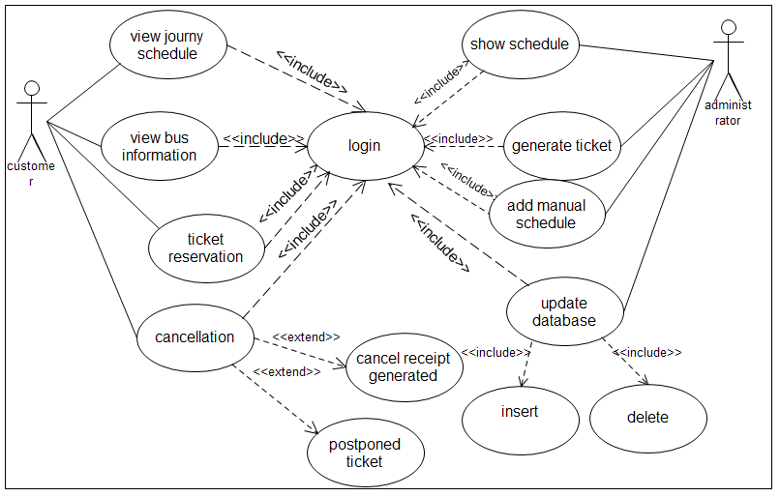

Figure use case diagram for proposed system

### 2.9.1. Essential Use case Description

***Use case documentation for Login***

|  |  |  |
| --- | --- | --- |
| Use case name | Login | |
| Use case number | UC1 | |
| Actor(s) | System administrator | |
| Description | The authentication for authorized system administrator in the system and deliver the right to visit the bus stations website that are allowed to be visited by customers. | |
| Basic course of action | **Actors action**  **Step 1** the system administrator initiate to login  **Step 2 :** the system administrator enter user name and password. | **systems response**  **Step 2:** The system displays the login form.  **Step 4:** The system checks the validity of the entry and then verifies whether the administrator is authenticated and authorized.  **Step 5:** If the administrator is authenticated & authorized for the tasks the system displays the main page for further action. |
| Alternate courses of action | **Step 3:** If the administrator’s entry (user name and Password) is not validated and verified the system displays error message and return to step 2. | |
| Pre-condition | The administrator should inter the correct password and user name. | |
| Post condition | The administrator able to access the required main page. | |

Table use case for login

* ***use case Documentation for Customer Reservation***

|  |  |  |
| --- | --- | --- |
| UC- name | Customer Registration | |
| Use case number | UC1 | |
| Actor | Customer | |
| Description | New customer reserve services required from the bus station system. | |
| Basic course of action | **Actor Action**  **Step1**: Customer wants to reserve service from the bus station.  **Step3**: Customer enters all required information in the reservation form.  **Step4:** Customer click on the submit button after information filled.  **Step7:** Customer gets the serial number for the reserved services | **System Response**  **Step2**: System displays customer reservation form.  **Step 5:** System checks the validity the filled information.  **Step 6:** the system accepts customer data and stored in to DB |
| Alternative courses of action | **Step 5:** if the required reservation according to the filled information is not available, then the system show alert “sorry the available services are all reserved”. | |
| Pre-condition | Customer requires online reservation for bus ticket. | |
| Post condition | Customer acquire reservation serial number successfully unless receive an alert “sorry the available services are all reserved”. | |
|  |  | |

Table use case for customer registration

* ***use case Documentation for cancellation***

|  |  |  |
| --- | --- | --- |
| UC- name | ***Ticket request cancellation*** | |
| Use case number | UC2 | |
| Actor | Customer | |
| Description | Customer require to cancel ticket reserved to get service | |
| Basic course of action | **Actor Action**  **Step1**: customer wants to cancel bus ticket reservation.  **Step3**: customer enters serial number for the reserved service **Step4:** customer submits the information filled. | **System Response**  **Step2**: System displays cancellation form.  **Step 5:** System checks the validity the filled information.  **Step 6:** the system accepts cancellation request based on the customer serial number. |
| Alternative courses of action | **Step 5:** if the entered serial number not available show an alert “cancellation failed try again with the correct serial number. | |
| Pre-condition | Customers must have serial number for the reserved service. | |
| Post condition | If the entered serial number is correct, “successfully cancelled the  Reservation” unless the serial number is correct “cancellation failed please try again with the correct serial number”. | |

Table use case for cancellation

* ***use case Documentation for update***

|  |  |  |
| --- | --- | --- |
| Use case name | ***Update*** | |
| Use case number | UC3 | |
| Actor | System Administrator | |
| Description | System Administrator need to update available and finished services | |
| Basic course of action | **Actor Action**  **Step1**: system administrator enters user name and password.  **Step3:**system administrator opens update form from the home page  **Step4**: system administrator fills in the required task such as insert or deletes to make the change in the data base.  **Step6:** system administrator receive an alert “successfully saved” or “successfully deleted” | **System Response**  **Step2**: System displays the update link to delete or insert data.  **Step 5:** the system save the entered data or delete the required data to be deleted. |
| Alternative courses of action | **Step 1:** if the system administrator enters the wrong password, show an alert “invalid password”. | |
| Pre-condition | Being an administrator | |
| Post condition | Show an alert “successfully deleted” or “successfully added ” | |

Table use case for update

* ***use case Documentation for view journey schedule***

|  |  |  |
| --- | --- | --- |
| Use case name | ***View Journey Schedule*** | |
| Use case number | UC6 | |
| Actor(s) | Customer | |
| Description | Every customer can view the schedule of bus station without go to station office | |
| Basic course of action | **Actor Action**  **Step1:** customer knows the website of station then access the webpage.  **Step3:** customer opens journey schedule since free. | **System Response**  **Step2:** System displays the webpage.  **Step4**: the system displays the schedule. |
| Pre-condition | Customer must know the bus station website | |
| Post condition | Customers view journey schedule. | |

Table use case for journey schedule

* ***use case Documentation for View Bus Information***

|  |  |  |
| --- | --- | --- |
| Use case name | ***View Bus Information*** | |
| Use case number | UC7 | |
| Actor(s) | Customer | |
| Description | Every customer can view bus information that the bus station arranges. | |
| Basic course of action | **Actor Action**  **Step1:** customer knows the website of station then access the webpage.  **Step3:** customer opens the profile of bus information | **System Response**  **Step2:** System displays the webpage.  **Step4**: the system displays bus information with detailed information. |
| Pre-condition | Customer must know the bus station website | |
| Post condition | Customers view bus information this is used for customer select the bus while registering. | |

Table use case for bus information

***Use case documentation for Add manual Schedule***

|  |  |  |
| --- | --- | --- |
| UC-name | ***Add manual Schedule*** | |
| Use case number | UC10 | |
| Actor | System Administrator | |
| Description | The System administrator shows the manual schedule on the web page. | |
| Basic course of action | **Actor Action**  **Step1**: System Administrator wants to show schedule.  **Step3**: System Administrator fills the form then click Save. | **System Response**  **Step2**: Add manual order form displayed.  **Step 4:** System checks the validity the filled information.  **Step 5:** the system save data filled to DB, finally the schedule is Shown for every customer. |
| Alternative courses of action | **Step 4:** if the information filled is not valid, then enter data again (Return step 2). | |
| Pre-condition | done manual schedule | |
| Post condition | Generate manual schedule on the webpage. | |

Table use case for add manual schedule

# CHAPTER THREE

## 3. System Design

**Introduction**

In this chapter we are intended to show the overall design of the system. This section deals with the decomposition of the system into different subsystems, proposed system architecture, sequence diagram for each use case, activity diagram, class diagram, collaboration diagram, state chart diagram, component diagram, deployment diagram and other essential issues of the design phase such as the system access control and security and data persistence management.

To increase the system, Efficiency, Flexibility Security and Reliability.

## 3.1 Subsystem decomposition

Subsystems decomposition is a general approach to solve a problem by breaking it up into smaller ones and solving each of the smaller ones separately, either in parallel or sequentially. Subsystem decompositions will help reduce the complexity of the system**.**

**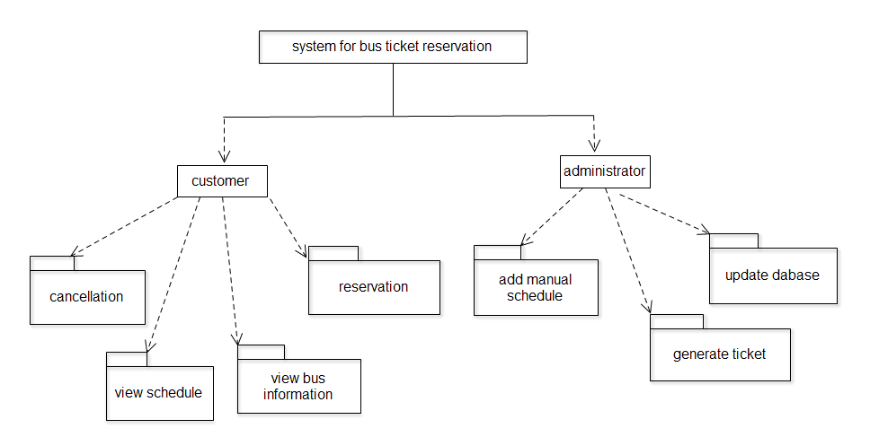**

Figure sub system decomposition

## 3.2 Proposed System Architecture

The purpose of designing is to show the direction as to how application is developed and to obtain clear and enough information needed to derive the actual implementation of the Application. The work is based on the services provided in the internet to customer. Once the services is available based on the customer request the services will be delivered with each specific privilege to access, to receive, to visit site.

The architecture used for the system is a 3 tier Client/Server Architecture where a client can use Internet browsers to access the online bus bus ticket reservation system within the Local area network of the school or anywhere using the Internet. The data tier maintains the applications data such as ticket request, generate ticket, view bus information, view journey schedule, register customer, register bus owner, confirm cost, show manual schedule, view ticket. It stores these data in a relational database management system (RDBMS). The middle tier (web/application server) implements the business logic, controller logic and presentation logic to control the interaction between the application’s clients and data. The controller logic processes client requests such as requests ticket and show services provided the bus station services from the database. Business rules enforced by the business logic dictate how clients can and cannot access application data and how applications process data.

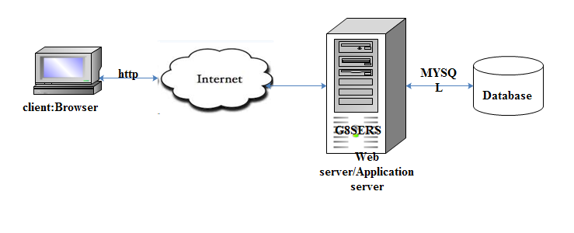

Figure proposed system architecture

## 3.3. Sequence Diagrams for each use case

**Definition**

A sequence diagram is an interaction diagram that details how operations are carried out: what messages are sent and when. Sequence diagrams are organized according to time. The time progresses as you go down the page. The objects involved in the operation are listed from left to right according to when they take part in the message sequence

1. Sequence diagram for login

Figure sequence diagram for login

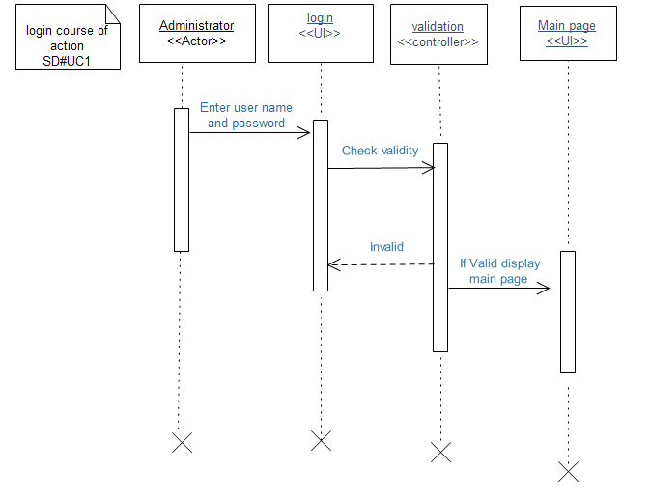

2. Sequence diagram for reservation

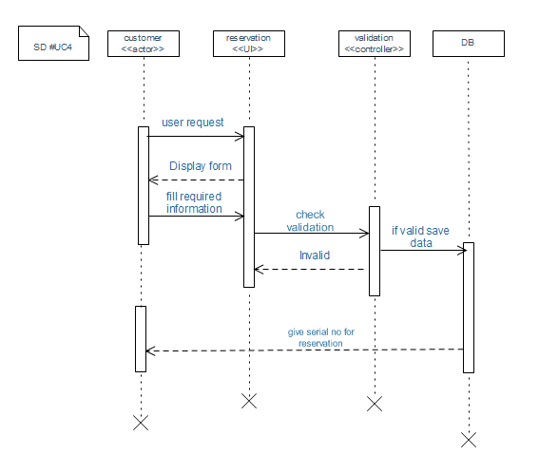

Figure 8 seqence diagram for reservation

3.Sequence diagram for journey schedule

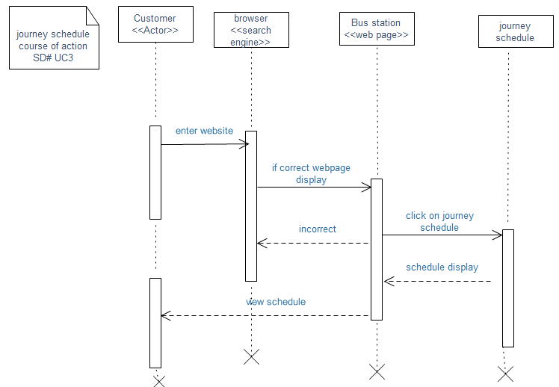

Figure sequence diagram for journey schedule

4. Sequence diagram for profile

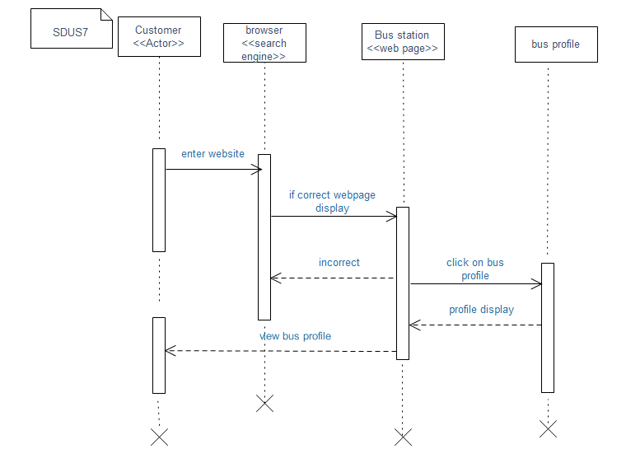

Figure sequence diagram for bus information

5.Sequence diagram for canclletion

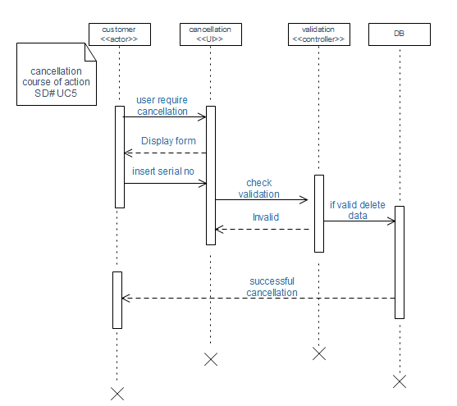

Figure sequence diagram for cancellation

6.Sequence diagram for add manual shedule

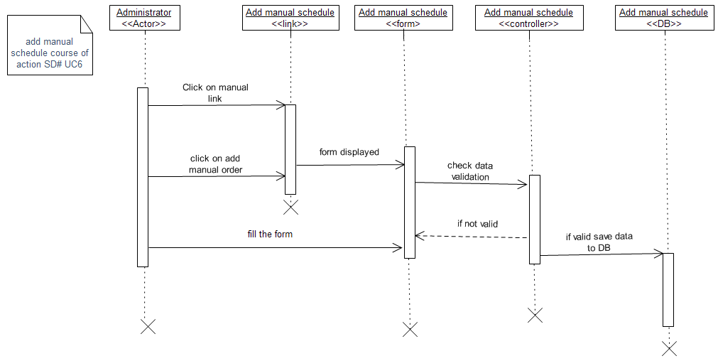

Figure sequence diagram for add manual sechedule

7.Sequence diagram for generate ticket

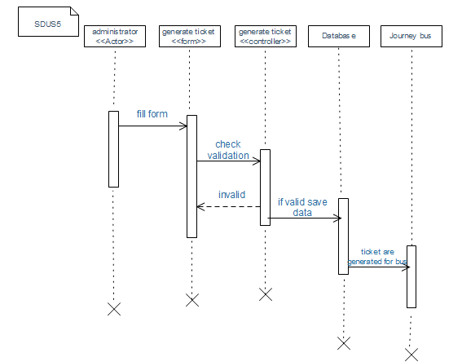

Figure sequence diagram for generate ticket

8 sequence diagram for update

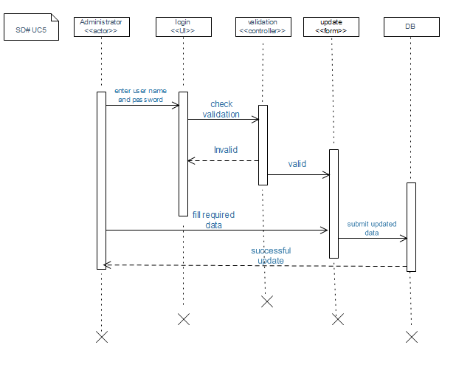

Figure sequence diagram for update database

## 3.4 activity diagram

**Definition**

Activity diagram is another important diagram in UML to describe dynamic aspects of the system. Activity diagram is basically a flow chart to represent the flow form one activity to another activity. The activity can be described as an operation of the system. So the control flow is drawn from one operation to another. This flow can be sequential, branched or concurrent. Activity diagrams deals with all type of flow control by using different elements like fork, join etc. In projects in which use cases are present, activity diagrams can model a specific use case at a more detailed level.

1. Activity diagram for login

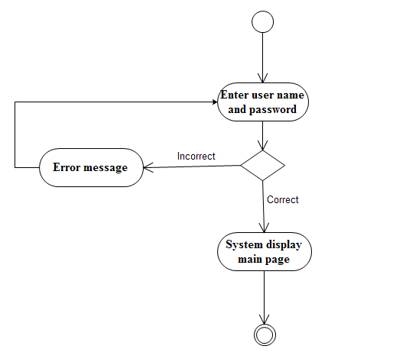

Figure 15 activity diagram for login

2 activity diagram for reservation

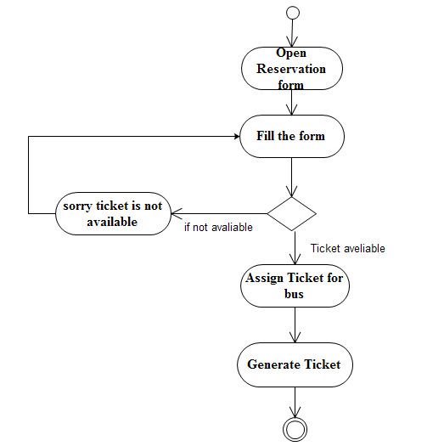

Figure 16 activity diagram for reservation

3. Activity diagram for view schedule

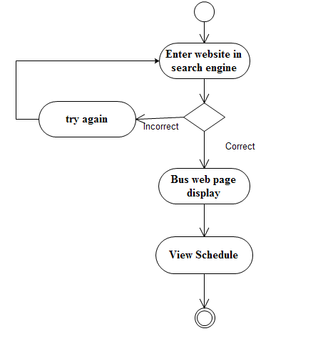

Figure 17 activity diagram for view schedule

4. Activity diagram for bus information

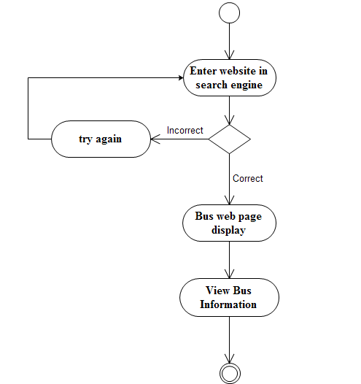

Figure 18 activity diagram for bus information

5. Activity diagram for generate ticket

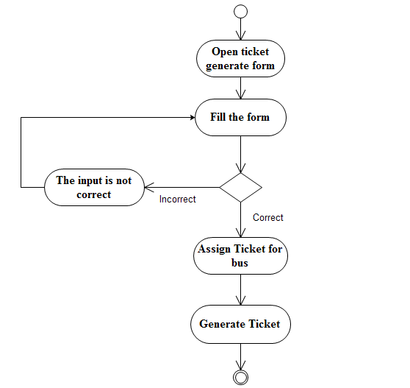

Figure activity diagram for generate ticket

6. Activity diagram for cancellation

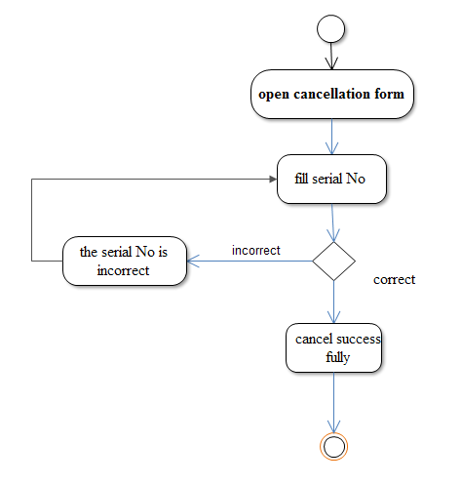

Figure 20 activity diagram for cancellation

7. Activity diagram for add manual

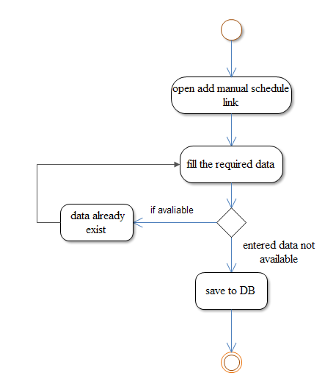

Figure activity diagram for add manual schedule

## Proposed system user interface prototype

## 

Figure 22 user interface for home page

## 

Figure 23 user interface for admin login

## 3.5. Class Diagram

The class diagram of UML is the central piece in a design or model. As the name suggests, these diagrams describe the classes that are there in the design. As the final codes of an OO implementation are mostly classes, these diagrams have a very close relationship with the final code.

**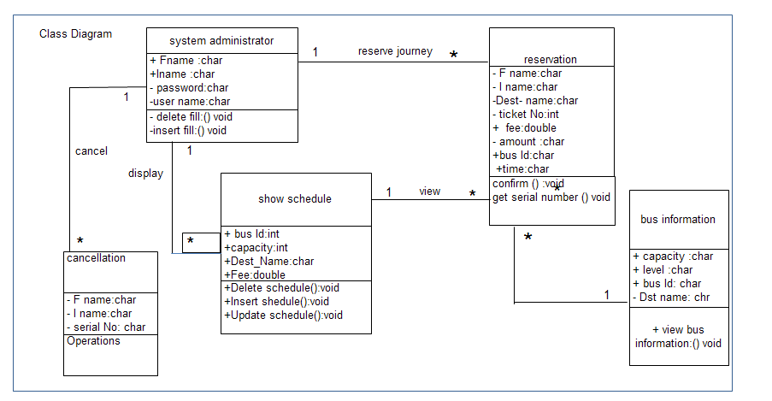**

Figure 24 class diagram for proposed system

## 3.6. Collaboration diagram

**Domain Modeling using CRC**

Class Responsibility Collaborator (CRC) Modelling is a method to gather and define the user requirements for an object-oriented application. The output of CRC Modelling is a CRC Model which is a collection of CRC cards that represent the whole or part of an application or problem domain. Each CRC Card in the model represents a class in the solution. A class represents a person, place, thing, event, concept, screen, or report that is relevant to the system at hand. The name of the class appears across the top of the card. A responsibility is anything that a class knows or does.

1. CRC administrator login

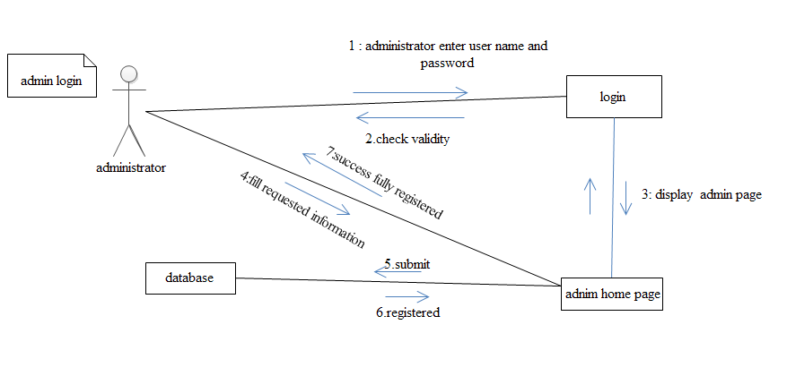

Figure 25 collaboration diagram for login

2. CRC for generate ticket

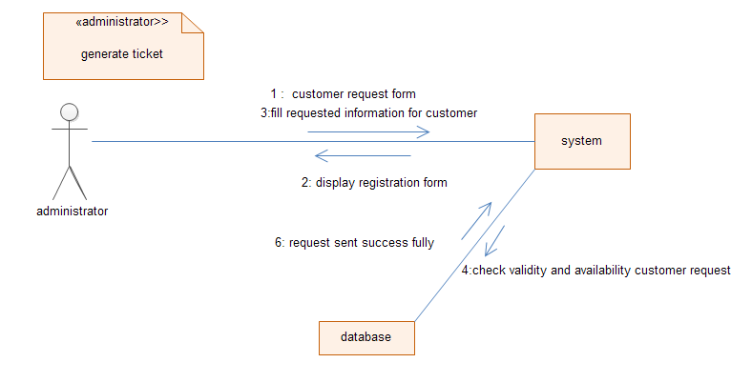

Figure collaboration diagram for generate ticket

3. CRC for view schedule

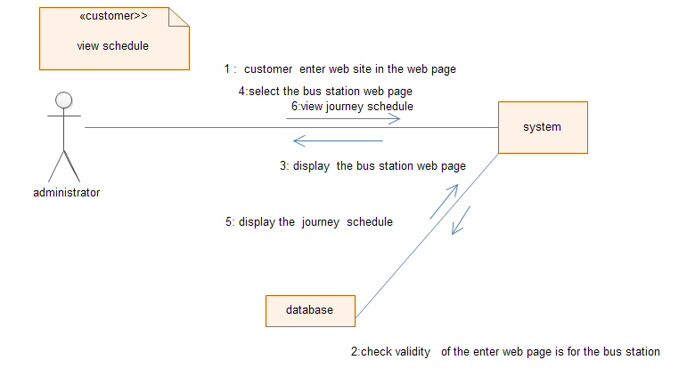

Figure 27 collaboration diagram for view schedule

4. CRC for view profile

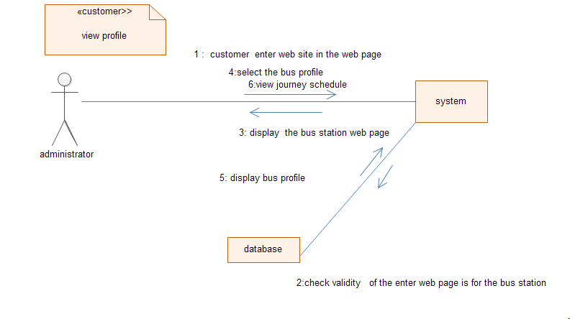

Figure 28 collaboration diagram for view profile

5CRC for add manual schedule

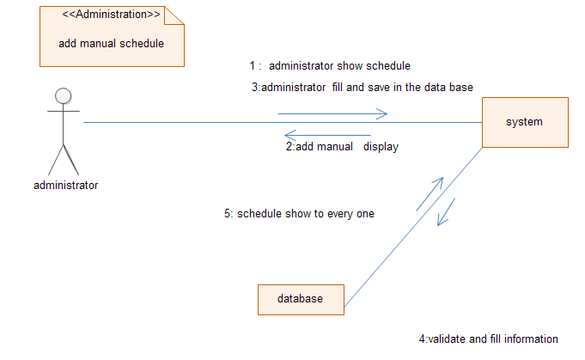

Figure collaboration diagram for add manual schedule

6. CRC for reservation

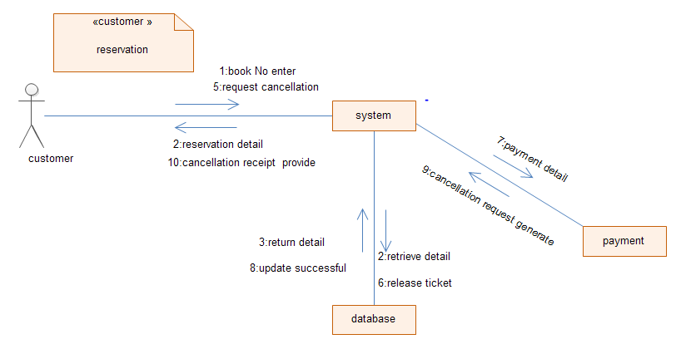

Figure 30 collaboration diagram for reservation

7. CRC for cancellation

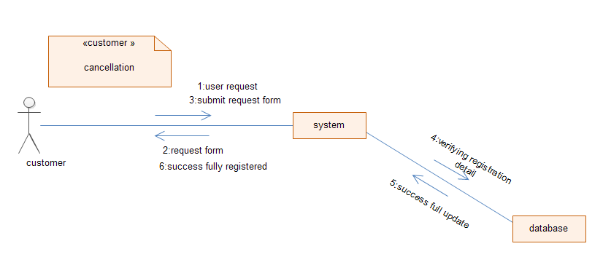

Figure 31 collaboration diagram for cancellation

## 3.7. State Chart diagram

State chart diagram is one of the five UML diagrams used to model dynamic nature of a system. They define different states of an object during its lifetime. It describes the flow of control from one state to another state. States are defined as a condition in which an object exists and it changes when some event is triggered.

The Following are the main purposes of using State chart diagrams:

* To model dynamic aspect of a system.
* To model life time of a reactive system.
* To describe different states of an object during its life time.
* Define a state machine to model states of an object

1 state chart for login

Figure 32 state chart diagram for login

Figure 33 state chart diagram for reservation

Reservation state

Diagram

**User select reservation page**

**Select customer reservation form**

**User enters required attributes**

**Enter attributes**

**Display invalid input**

**Viewing message**

**System register customer**

**Save input data**

**Valid**

**Invalid**

**Re enter**

**ENTER**

**The system check the validity**

**Check validity**

3 state chart for cancellation

Figure 34 state chart diagram for cancellation

Cancellation state

Diagram

**User select cancellation page**

**Select cancellation form**

**User enters serial no**

**Enter attribute**

**Display invalid input**

**Viewing message**

**System register customer**

**Save input data**

**Valid**

**Invalid**

**re enter**

**ENTER**

**The system check the validity**

**Check validity**

4 state chart for add manual

Figure state chart diagram for add manual schedule

Add manual schedule

State

Diagram

**System display form**

**Select add manual schedule page**

**User enters schedule**

**Enter attributes**

**Display invalid input**

**Viewing message**

**System display schedule**

**Save input data**

**Valid**

**Invalid**

**Re enter**

**ENTER**

**The system check the validity**

**Check validity**

## 3.8. Component diagram

Component diagrams show how the physical components of a system are organized. And also shows which component or objects will be accessed by whom and what type of security infrastructures it is using. The diagram is simulated below

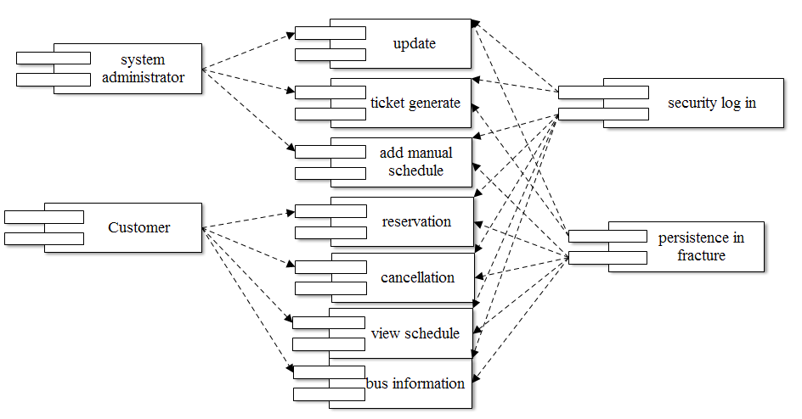

Figure 36 component diagram for proposed system

## 3.9. Deployment modelling

A UML Deployment diagrams are used to depict the relationship among runtime components and hardware nodes. Components are Self-contained entities that provide services to other components or actor.

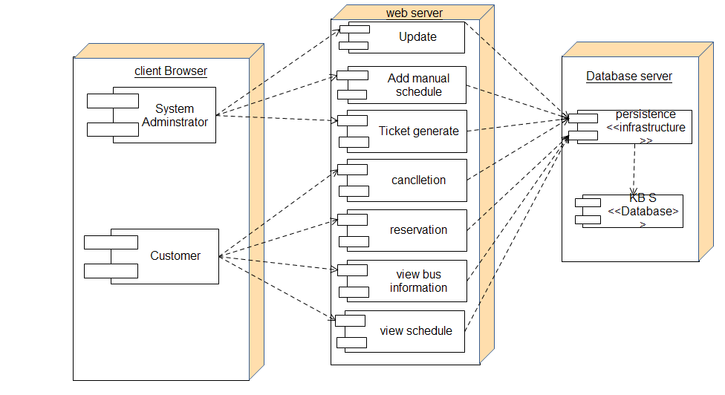

Figure 37 deployment diagram for proposed system

* 1. **Access control and security**

Access control and security describes user model of the system in terms of an access privilege. It is a system integrator and provides electronic security solutions to industry and the corporate sector. It involves managing who has access to specific system and resources at a given time.

But in our case the system can be access by using customer or administrator privilege but noncustomer can visit web page for the bus station without any privilege at anywhere and anytime.

Users Privilege assigned

All customer should be registered for ticket request by providing necessary information at the time they fill the form to get bus ticket reservation.

|  |  |
| --- | --- |
| User | Privilege |
| Administrator | Using own user name and password access, retrieve ,update available services and delete reserved services from the bus station |
| Customer | Being member for the services can reserve bus ticket based on the available services in the bus station |
| Noncustomer | View bus information and view schedule without privilege by just searching the web page for the bus station |

Table 3 1: access control and security

**B.Persistent data management**

Persistent data is a data structure that preserves its old versions; that is, both previous and current versions may be queried. Persistent data exists outside of an application’s active memory, typically in a database or flat file system. Data is the most important asset of any application. The main point of our system is to provide fast, accurate, satisfactory and time and money saving services to customer.

Object diagram

Object diagram is a simple tool that shows objects and the connection between them. When you depict an object you need to include enough information so that it becomes recognizable instance. Object diagram is effectively notational subset of communication diagrams. Object diagram uses a notation similar to class diagram and is used to illustrate an instance of a class at particular point in time.

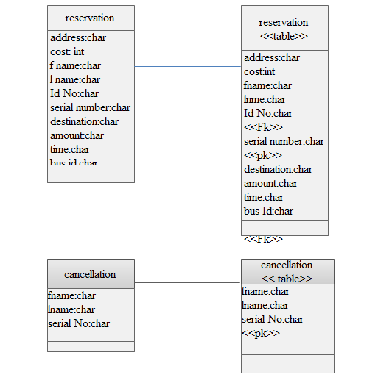

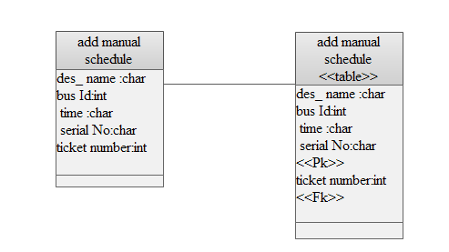

# Appendix

|  |  |  |  |  |  |  |  |  |  |
| --- | --- | --- | --- | --- | --- | --- | --- | --- | --- |
| Student name | Student id | | present | | Absent | Date of contact | Agenda discussed | decision made | Assign for next week |
| 1)Beydu awol | GUR/1331/04 | |  | |  | 1s week26/02/2007 | Find to select Title  And Discus the main problem of the organization | Select the title  Online bus ticket reservation  Team member list out the main problem | Decide to go the organization  And gather information |
| 2)Habtamu Bekele | GUR/1396/04 | |  | |  |
| 3)Mikrie dubie | GUR/1472/04 | |  | |  |
| 4)Nigatu Mengie | GUR/1487/04 | |  | |  |
| 1)Beydu awol | GUR/1331/04 | |  | |  | 2nd week03/03/07 | Find out problem of organization | Find solution and summarize the topic | Decide to organized the proposal |
| 2)Habtamu Bekele | GUR/1396/04 | |  | |  |
| 3)Mikrie dubie | GUR/1472/04 | |  | |  |
| 4)Nigatu Mengie | GUR/1487/04 | |  | |  |
| 1)Beydu awol | GUR/1331/04 | |  | |  | 3rd week10/03/07 | Made organize the proposal | Arrange in organized form | Decide to contact our adviser at time weekly |
| 2)Habtamu Bekele | GUR/1396/04 | |  | |  |
| 3)Mikrie dubie | GUR/1472/04 | |  | |  |
| 4)Nigatu Mengie | GUR/1487/04 | |  | |  |
| 1)Beydu awol | GUR/1331/04 | |  | |  | 4th week  15/03/07 | About the proposal defense preparing. | Arrange and prepare for defense | Decide how to defense on the time of proposal defense |
| 2)Habtamu Bekele | GUR/1396/04 | |  | |  |
| 3)Mikrie dubie | GUR/1472/04 | |  | |  |
| 4)Nigatu Mengie | GUR/1487/04 | |  | |  |
| Proposal defense date 20/03/ 07 | | | | | | | | | |
| 1)Beydu awol | GUR/1331/04 | | |  |  | 5th week 13/04/07 | Starting Analysis phase | Discuss about the requirement gathering | Decide how to analysis the current system problem |
| 2)Habtamu Bekele | GUR/1396/04 | | |  |  |
| 3)Mikrie dubie | GUR/1472/04 | | |  |  |
| 4)Nigatu Mengie | GUR/1487/04 | | |  |  |
| 1)Beydu awol | GUR/1331/04 | | |  |  | 6th week  22/04/07 | Study use case of existing and proposed system | Arrange draw the use case for the existing system and proposed system | Decide for the next topic like description for use case |
| 1)Beydu awol | GUR/1331/04 | | |  |  |
| 2)Habtamu Bekele | GUR/1396/04 | | |  |  |
| 3)Mikrie dubie | GUR/1472/04 | | |  |  |
| 4)Nigatu Mengie | | GUR/1487/04 | |  |  | 7th week  28/04/07 | To reading system design | Read more about introduction of system design and what are included in design | The team draw for each designs what included in the designing part |
| 2)Habtamu Bekele | | GUR/1396/04 | |  |  |
| 3)Mikrie dubie | | GUR/1472/04 | |  |  |
| 4)Nigatu Mengie | | GUR/1487/04 | |  |  |
| 1)Beydu awol | | GUR/1331/04 | |  |  | 8th week  4/05/07 | Arrange the whole document | Arrange according to guideline of the project | Finally team get approved from adviser |
| 2)Habtamu Bekele | | GUR/1396/04 | |  |  |
| 3)Mikrie dubie | | GUR/1472/04 | |  |  |
| 4)Nigatu Mengie | | GUR/1487/04 | |  |  |